Investment Portfolio Check-Up

- Have you seen a dramatic drop in your account value?
- Have you seen transactions and investments in your account which you do not recognize or were not authorized for purchase?

- Has your monthly income check from your account decreased? Or did it cease?

- Is your broker/financial advisor not responding to your calls or emails?

- Does your account show that you are on trading on margin and you never discussed the risks with your financial advisor associated with trading on margin?

- Has your broker/advisor asked you for a loan?

- Are you unable to access your money for basic living expenses because it is invested in illiquid assets?

If you answered YES to any of these questions, PLEASE call an attorney.

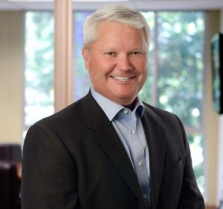
Since 1990, Mr. Gonser has practiced in the securities area focusing on matters involving disputes between investors and their financial advisors. Bob started his career with a major defense firm in San Francisco defending stock brokers and national brokerage firms, but since 1995, has utilized his many years of defending those firms and financial advisors to assist public customers who have been damaged by improper and illegal sales practices conducted by their financials professionals. Bob has successfully handled hundreds of cases before the Financial Industry Regulatory Authority (FINRA), the NASD, the NYSE and the PSE involving losses sustained by his clients in brokerage accounts from the mismanagement and, in some instances fraudulent conduct by brokers, Registered Investment Advisors and various and brokerage firms. Over the years, his efforts have resulted in millions of dollars in the form of awards and settlements for his clients. Bob typically is retained in these matters on a contingent fee basis which means that he essentially partners with his clients in order to achieve recovery of losses sustained due to an Advisor’s misconduct.
Robert L. Gonser, Esq.
Gonser Law PC
3717 Mt. Diablo Blvd.
Suite 210
(925) 310-4408

