Resource Guide
For
Estate Organizing

Estate Planning Professionals:
For a directory of estate planning councils in your area, or to locate an estate planning professional near you, visit the National Estate Planning Council website.
http://www.naepc.org/

Professional Fiduciaries:
To understand how a professional fiduciary might be able to help you or your family, visit the State of California’s Department of Consumer Affairs Website at https://www.dca.ca.gov/ or The Professional Fiduciary Association of California website.
https://pfac-pro.org/

Estate Organizers:
To find an Estate Organizer in your area, visit the National Association of Professional Organizer website.
https://www.napo.net/default.aspx

Medical Equipment Recyclers:
To donate your clean and gently used medical equipment and unused home health care supplies, or if you are in need of inexpensive or sometimes free medical equipment, visit the ReCARES website for instructions on how to do so.
http://www.homecares.org/

Hoarding Resources:
To find helpful information or find an organizer in your area that specializes in Chronic Disorganization and hoarding, visit The Institute for Challenging Disorganization website. https://www.challengingdisorganization.org/

Alzheimer’s Association:
To find help while dealing with a family member with Alzheimer’s visit the Alzheimer’s Association website.
https:// https://alz.org

Clutterers Anonymous:
Clutterers Anonymous is a 12-step fellowship where members share their experience, strength and hope to solve their common problem with clutter. To find a support group near you, visit their website.
https://clutterersanonymous.org/

US Department of Veteran’s Affairs:
To find information and eligibility for benefits for your veteran, visit the US Department of Veteran’s Affairs website.
https://www.va.gov/

Social Security Administration:
For information on Social Security benefits visit their website.
www.ssa.gov

Recycling and Waste Disposal (Northern California – East Bay):
El Cerrito Recycling Station
A place to recycle just about ANYTHING, including Styrofoam and Electronics. There is an exchange zone for books & CDs. Goodwill has a collection truck stationed there.
https://www.el-cerrito.org/533/Recycling-Environmental-Resource-Center
7501 Schmidt Lane, El Cerrito, CA
510-215-4350

Berkeley Transfer Station
For a minimum fee, accepts refuse, construction & demolition debris, yard waste & recyclables.
https://www.cityofberkeley.info/transferstation/
1201 Second Street, Berkeley, CA
510-981-6300

Hazardous Waste-Alameda County
http://www.stopwaste.org/recycling/residents/household-hazardous-waste/oakland-hhw-facility
2100 East 7th Street, Oakland, CA
800-606-6606

Hazardous Waste-West Contra Costa
101 Pittsburg Avenue, Richmond
510-231-4203

Donations (Northern California – East Bay):

East Bay Depot for Creative Reuse
A place to donate items that teachers and artists can use; paper, interesting items, furniture, etc…anything that can be made into art or used in the classroom.
http://creativereuse.org/
4695 Telegraph Ave, Oakland, CA
510-547-6470

Oakland Museum White Elephant Sale:
The sale is in March, but they take donations all year. To schedule a pick-up, call 510-839-5919.

Paper Shredding:
Berkeley Shreds
Destroys all types of data and documents. They also recycle electronics.
https://berkeleyshreds.com/
1464 Eastshore Highway, Berkeley, CA
877-54-SHRED

Shred Works
Destroys all types of data and documents, they also recycle electronics.
http://shredworks.com/
455 High Street, Oakland, CA
510-729-7110

Auction Houses:
Michaan’s Auctions is a full-service auction house. They hold monthly art and antique and estate auctions. They provide free on-site appraisals on Wednesdays 10 to 1.
https://www.michaans.com/
2751 Todd Street, Alameda, CA
800-380-9822

Clars Auctions is a full-service auction house. Based in Oakland, they hold monthly art and antique and estate auctions. They provide free on-site appraisals on Thursdays 9 to noon.
https://clars.com/
5644 Telegraph Avenue, Oakland
510-428-0100

Local Bulky Waste Pick-Up Programs - Each city provides one pick-up annually.
City of Berkeley, City of Oakland, City of Albany, City of El Cerrito

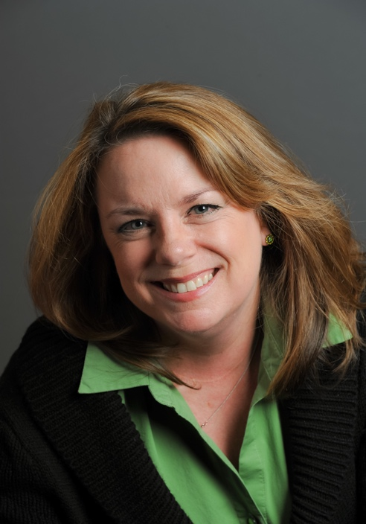
Meg Connell, Owner
The Organized One
Estate and Residential Organizing
(510) 482-5892
Meg@TheOrganizedOne.com
www.theorganizedone.com

Meg has been a professional organizer since 1996 and is a mother of one. She loves to craft, sew, create, organize and design. Her degree in interior design and her years in corporate America and the estate planning industry have created a unique set of interests which is apparent in the exceptional work she does with her clients.

